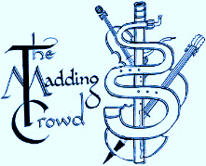
The Madding Crowd
Will perform At
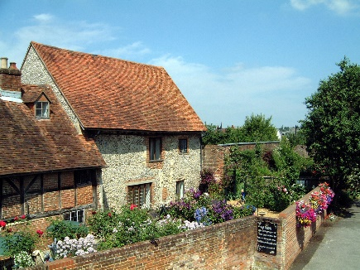
King John’s House
Church Street Romsey
SO51 8BT
0n the theme
Through all the Changing Scenes of Life
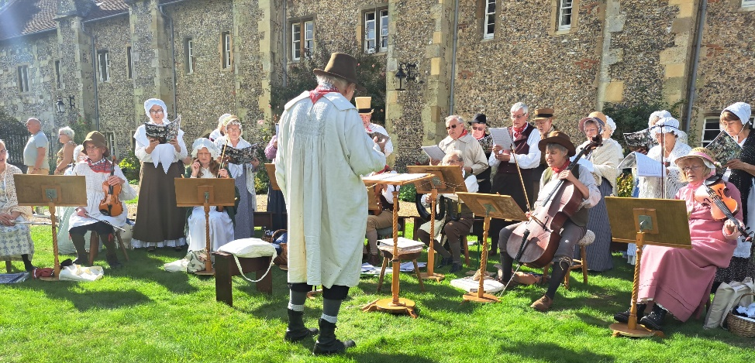
2pm to 4pm Saturday 4th May 2024
A rare opportunity to hear music that was played and sung by village bands throughout England in Georgian times, for entertainment and dancing as well as in church on Sundays.
There will also be short readings from contemporary sources that bring to life the social history of the time.
www.maddingcrowd.org

