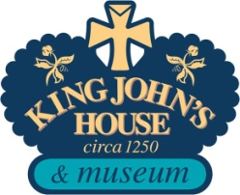

EVENT MENU

The team at King John’s House and Heritage Centre are delighted to cater for your event or group visit. If you would like a special menu prepared, just for you, please ask.

For Groups and Events
(For groups of 10+. With tea, coffee or a soft drink)

No Jacket Required
Jacket Potato with a choice of three delicious fillings; £7.50
Tuna, Homemade Coleslaw, Cheese or ‘as it comes’.

Bloomin’ Souper
A choice of two homemade soups with a bloomer sandwich £7.50

The Best Thing …
The Bloomer Sandwich £5.25

Sandwiches come with a choice of three fillings; ham and cheese, Tuna and Cucumber, Egg Mayonnaise

Traditional Cream Tea £5.75
Fruit or Plain Scone with homemade Jam and Clotted Cream

Start with Coffee or Tea on arrival or as required
Tea or Coffee and Biscuits or Danish Pastry £3.50

Classic Teas for a Special Occasion

Birthday Tea
Tea, coffee, soft drinks, sandwiches and cakes £8.75

Our Special High T
As the birthday tea with sausage rolls, cocktail sausages £9.75
‘baby’ pork pies, cheese and pineapple

